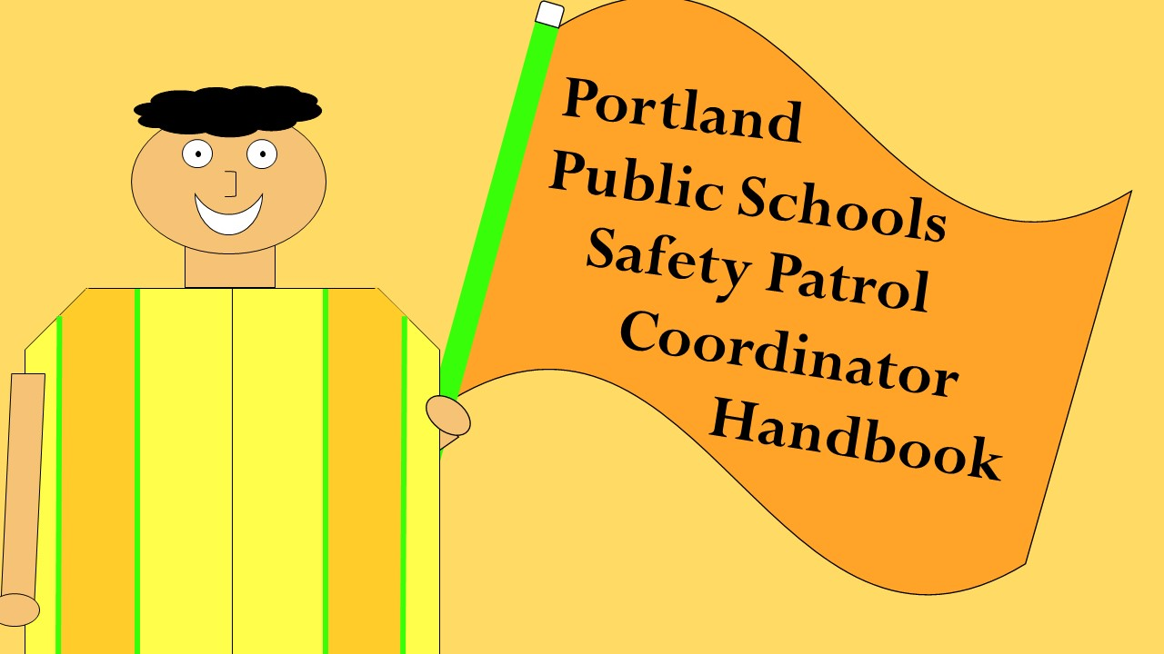

Updated: August 2024

Table of Contents

Safety Patrol vs. Crossing Guards 3

Safety Patrol Coordinator Responsibilities 4

Important Dates 5

Where to Station Your Safety Patrol 6

Selecting Safety Patrol Members 7

Training Safety Patrol Members 8

Equipment 9

Daily Operations of Your Safety Patrol 11

Drivers Failing to Yield 12

End of Year Celebration 13

Templates 14

Additional Resources 15

# Safety Patrol vs. Crossing Guards

While the terms “safety patrol” and “crossing guard” are frequently used interchangeably, Oregon law draws a distinction between the two. Crossing guards are adults responsible for assisting children in crossing the street safely on the path to and from school. This handbook utilizes the term “crossing guard” when referring to adult traffic patrol members and “safety patrol” when referring to students.

**Student Safety Patrol members should never stop traffic.** Student safety patrol is intended to increase visibility using high visibility gear and school flags for students who are engaging in their legal right-of-way when crossing, giving drivers more indication of the need to stop for pedestrians in the crossing.

Largely, adult crossing guards fulfill the same role as safety patrol members- providing increased visibility for students crossing in an area where they have legal right-of-way to cross. In limited circumstances and when utilizing proper tools, crossing guards may create gaps in traffic to assist students in safely crossing. For example, when wearing a Class 2 high-visibility vest and using a stop paddle at an unsignalized school crossing that does not provide a natural opening in traffic, an adult crossing guard may use the stop paddle to halt traffic and allow students to safely cross.

Adult crossing guards are typically used when the traffic situation at the school crossing is too hazardous to be handled by children.

Because crossing guards are typically employees of the district, OSHA requirements regulate crossing guard work in addition to Oregon traffic laws. Due to this, **failure of crossing guards to wear proper equipment when performing duties can result in OSHA violations that carry penalties**. Proper equipment includes high-visibility retroreflective safety apparel labeled as ANSI 107-2004 standard performance for Class 2 risk exposure and a yellow-green SCHOOL flag or stop paddle (see equipment section for more information).

Contact the Safe Routes to School (SRTS) Coordinator if you need crossing guard equipment at your school.

# Safety Patrol Coordinator Responsibilities

The safety patrol coordinator is responsible for the selection, training, and daily supervision of all safety patrol members. This handbook will examine the responsibilities of the safety patrol coordinator in-depth, but we have provided an overview of responsibilities below:

* Provide supervision for all safety patrol members when performing safety patrol duties
  + **Students may not perform safety patrol duties without supervision by a trained staff member**
  + **If safety patrol members are observed performing safety patrol duties without appropriate supervision, your safety patrol program will be disbanded and will not participate in the end of year celebration**
* Identify potential safety patrol members
* Distribute, collect, and facilitate signatures of safety patrol permission slips
* Develop a safety patrol training utilizing the Safety Patrol Training Presentation template provided by the district
* Train safety patrol members on all duties related to the position and provide coaching when members are not exhibiting skills as trained
* Develop and maintain a safety patrol schedule that is communicated to all safety patrol members and necessary school staff
* Support the Safe Routes to School Coordinator in organizing the end of year safety patrol celebration by collecting and submitting Wilderness Field Trip permission slips, arranging transportation, and accompanying students to the celebration
* Maintain safety patrol equipment provided by PPS and communicate with the Safe Routes to School Coordinator if replacement equipment is needed
* Coordinate community messaging notifying the school community when safety patrol becomes active for the year and providing essential safety rules for traveling around school grounds
* Complete annual “Safety Patrol Coordinator Training” within the PepperPD platform prior to October 31st. Safety patrol should not be activated at your school until you have completed this training.

# Important Dates

Schools are not required to start the safety patrol at the beginning of the year, giving students and staff time to adjust to the school routine and an opportunity for the safety patrol coordinator to organize for the school year and identify which students might be the best fit for the safety patrol.

The dates below are recommendations for you to prepare for the school year and be proactive in collecting necessary information for the safety patrol celebration at the end of the year. PepperPD training must be completed by the Safety Patrol Coordinator prior to activating the safety patrol.

Concrete deadlines will be communicated via Admin Portal and email as dates are confirmed for the end of year celebration. It is your responsibility to ensure these deadlines are met so that the celebration is prepared for an accurate number of students.

**September 30th, 2024** - Begin planning for this year’s safety patrol team/send home applications

**November 1st, 2024** - Applications/permission slip to participate on safety patrol due

**One Week Before Safety Patrol Begins** - Send out [community messaging](https://docs.google.com/document/d/1qHb-NsROEeXiH-em07eVpqmDXi4sVh8vra4A-VWhAHQ/edit?usp=sharing) notifying safety patrol is active, provide essential safety rules for traveling around school grounds

**January 31st, 2025** – Submit all safety patrol permission slips to SRTS Coordinator for headcount for end of year celebration

**If a student transfers to your school mid-year, the student may be invited to join safety patrol. Please submit new permission slips to SRTS Coordinator ASAP.**

**Mid-February** - Send home Wilderness Field Trip Permission Slip form for end of year celebration (must be returned to participate at end of year celebration)

**Mid-March** – Final count for Safety Patrol End of Year Celebration due

**At least three weeks before Safety Patrol End of Year Celebration** - Bus must be scheduled through [Student Transportation office](https://www.pps.net/Page/168)

**Last week in May/First Weeks of June** – Safety Patrol End of Year Celebration (official date to be announced)

# Where to Station Your Safety Patrol

Safety patrol members should be stationed at crossing points adjacent to the school site with the most supportive infrastructure that already exists, such as marked crosswalks, which concentrates students and families to cross at the safest crossing(s). If your school wants to place patrol members at an unmarked crosswalk (an area not painted/striped), consult with the SRTS Coordinator for approval.

**Supervision**

A primary factor in placement of your patrol members will be your ability to actively supervise patrol members. Safety patrol members must be actively supervised by a trained staff member whenever performing duties that place the student in the street. A crosswalk may have a single safety patrol member or multiple members stationed at it, as long as the all students are within line of sight of the trained staff member. A staff member may manage multiple crossings if the staff member is within line of sight of each crossing and is within reasonable range to actively respond and support safety patrol members.

To ensure students are sufficiently supervised when performing duties, a plan should be developed with your school leadership to ensure a trained substitute is available to supervise students in your absence and someone is responsible for informing the substitute they are needed. If a substitute is not available, someone should be designated with the responsibility of informing safety patrol members that duties are canceled for the day so that they are not performing duties unsupervised.

# Selecting Safety Patrol Members

Selecting students to participate on the safety patrol is an important task at the beginning of the year to set your patrol and your school up for a safe and successful school year. Safety patrol coordinators should utilize the Safety Patrol Application template to create a safety patrol application for interested students. Safety patrol is open to **fourth and fifth grade students only.** You may choose to send out applications to all students within fourth and fifth grade or may choose to send applications only to classes in either or both of these grades whose schedules are conducive to the safety patrol schedule.

The safety patrol application also serves as a permission slip from the student’s guardian for serving on the safety patrol and as a commitment from the student to their safety patrol responsibilities. These applications are also used to secure a headcount for the district’s end of year safety patrol celebration, so it’s important to be thorough when collecting and organizing your applications to ensure all safety patrol members are accounted for.

Safety patrol members should be selected based on students’ demonstration of the following traits:

|  |  |
| --- | --- |
| * Leadership | * Maturity |
| * Reliability | * Punctuality |
| * Sound judgment | * Interest in traffic safety |
| * Obedience to rules | * Good attendance record |
| * Courtesy | * Respect for classmates |
| * Attitude of service toward others |  |

Safety patrol members must also be able to commit to the dates and shifts they are assigned.

Students and their families will need to be notified that they have been selected to participate on the safety patrol and when they will be expected to report for duty. You can use the Congratulations/Selection Letter template to provide students and families with this information.

# Training Safety Patrol Members

As safety patrol coordinator, it is your responsibility to ensure all safety patrol members are adequately trained in the skills and practices necessary for fulfilling their duties.

The Oregon Safety Patrol Manual requires students to be trained on:

* Fundamentals of traffic safety
* Duties of each patrol post
* Proper use of flags
* Correct cautioning of traffic
* Wearing of appropriate attire
* Use of good judgment
* Identifying sufficient gaps in vehicular traffic to permit safe crossing by students

To assist in training students and ensure that students across the district are receiving consistent training information, a Safety Patrol Training Template has been created that contains general information all patrol members must know, as well as space for you to provide photos of safety patrol stations, equipment storage, and other school-specific procedures students should know.

After students have been trained using the presentation, take students out to the crossings where they will be posted to review how safety patrol skills will be put into use. Demonstrate how safety patrol members should act when in “neutral” position at rest and when assisting students in crossing. Allow students to practice and provide feedback as needed.

# Equipment

A variety of equipment is used by safety patrol members to fulfill their duties and stay safe and comfortable while doing so.

**Mandatory**

The district provides the mandatory equipment students must **always** use when performing safety patrol duties. Students are required to wear high-visibility retro reflective safety apparel labeled as ANSI 107-2004 standard performance for Class 1 risk exposure. The apparel background (outer) material color must be fluorescent yellow-green. The retroreflective material shall be either orange, yellow, white, silver, yellow-green or a fluorescent version of these colors and shall be visible at 1,000 feet. Students must also use a flag made from bright or fluorescent colors with STOP visible on both sides of the flag. Images of these items are below:

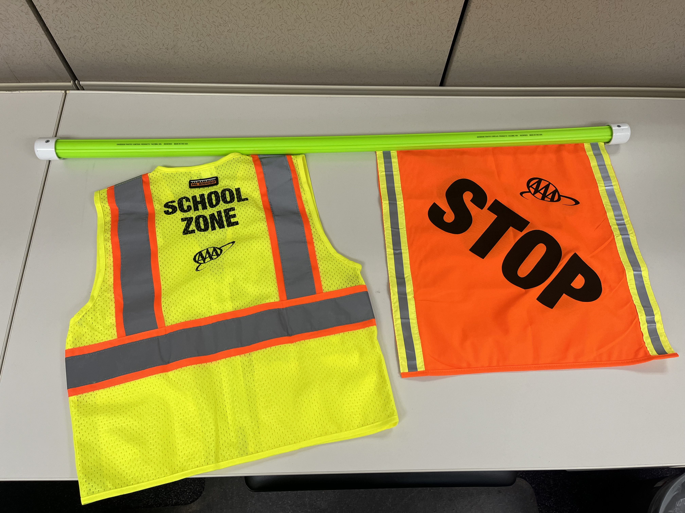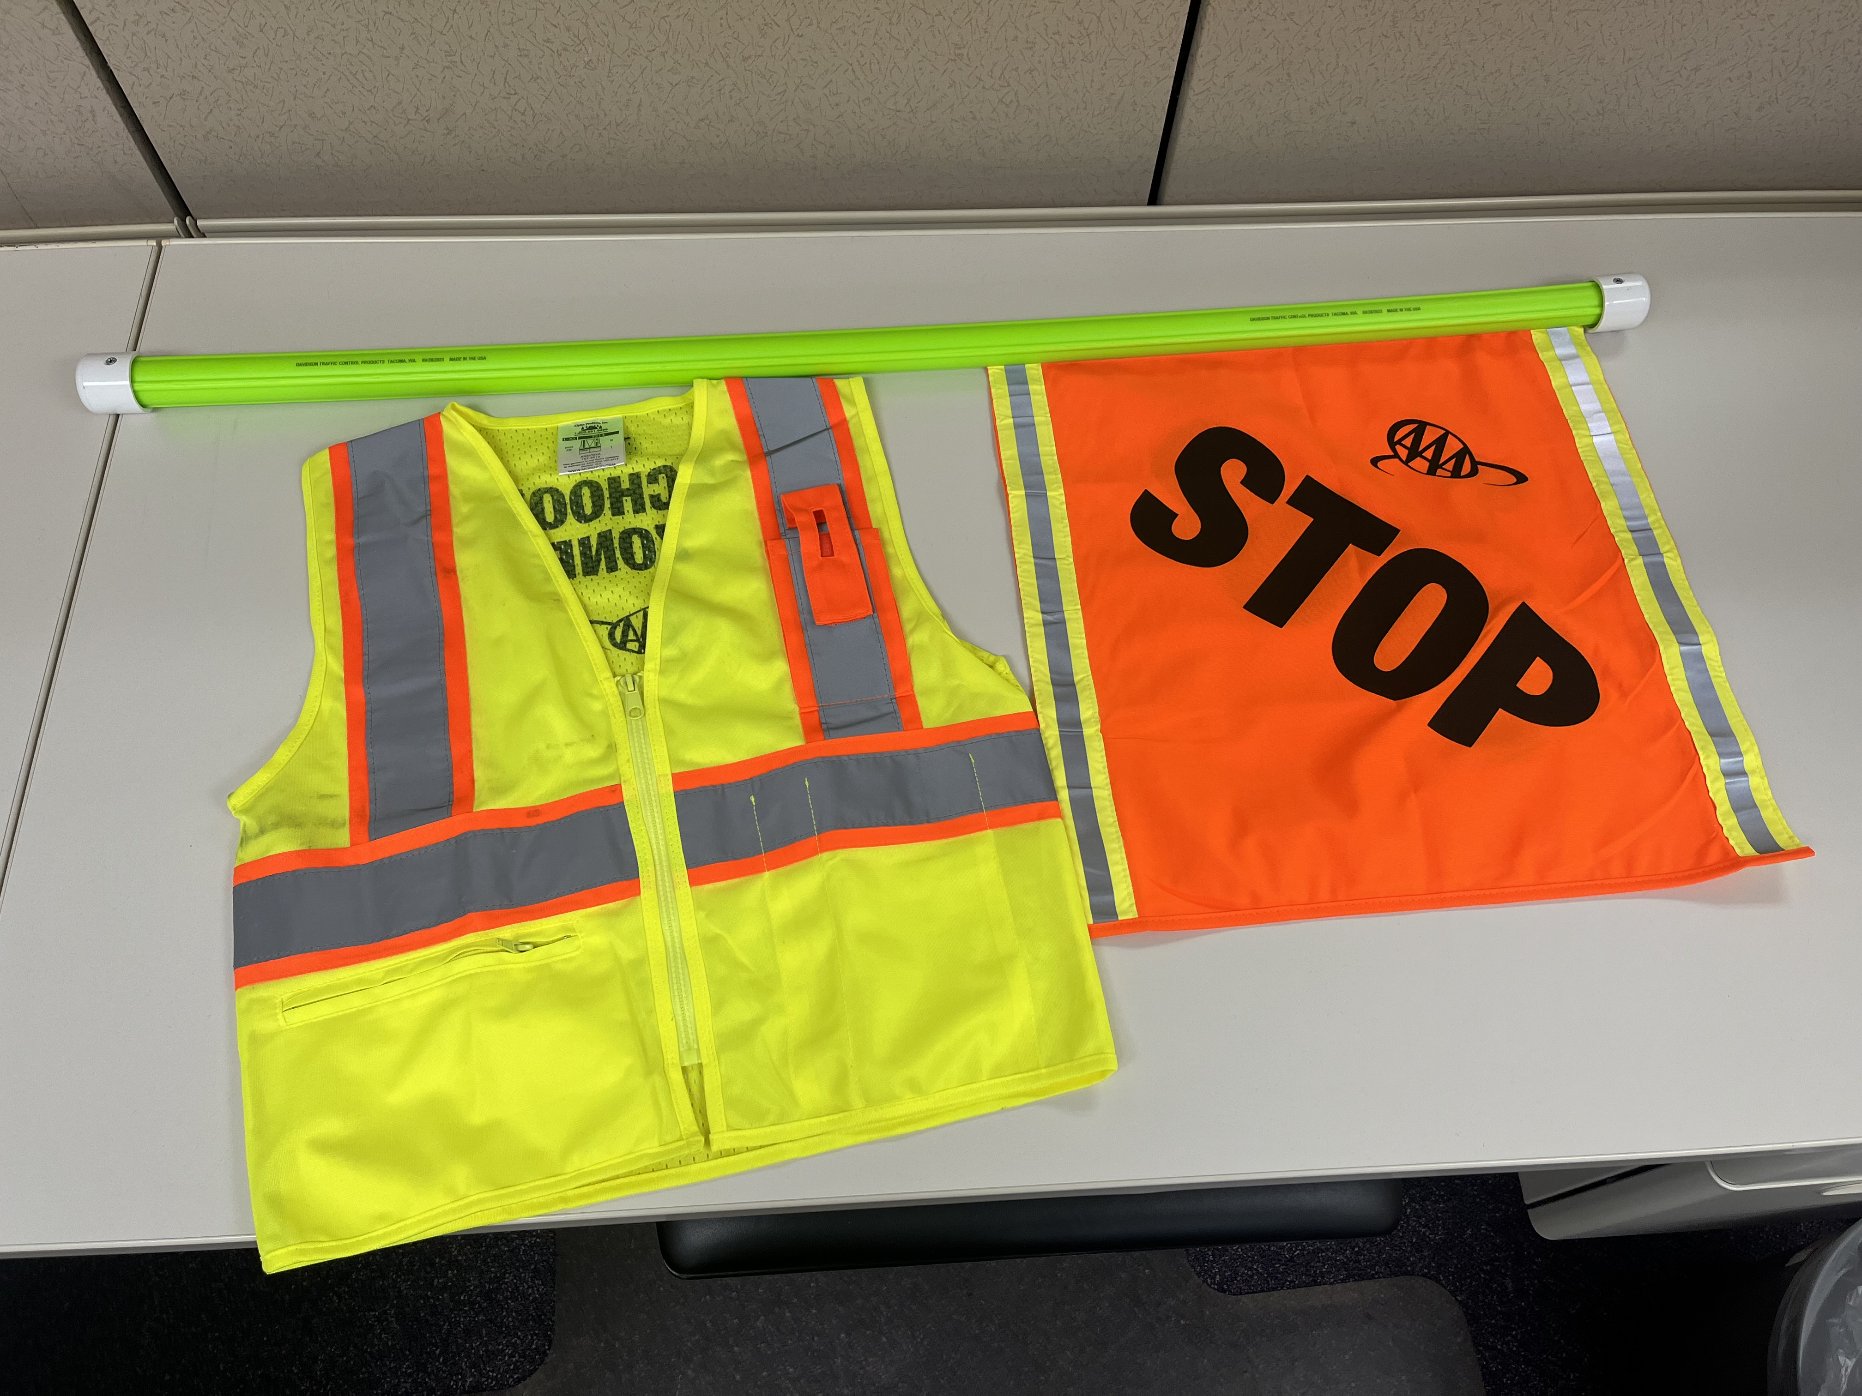

Students must always wear the high-visibility vest as the outermost layer of their clothing. This means during colder weather or rainy days, students should first put on a raincoat or winter jacket, then put the high-visibility vest on outside of the coat.

Vests come in child sizes of *Small/Medium* and *Large/Extra Large*. Please specify how many of each size are needed. If these vest sizes are inadequate for your students’ needs, contact the SRTS Coordinator to arrange for alternative vests.

**Optional**

Other equipment can be purchased for the safety patrol using funding from the school’s budget or from PTA or other organizations’ donations or fundraising. Common equipment schools purchase includes rain gear, such as yellow rain ponchos or umbrellas; hats and gloves; or additional visibility gear such as reflective bracelets or buttons.

Schools may also apply for a [Metro SRTS Micro-Grants](https://oregonmetro.wufoo.com/forms/metro-rto-small-grants-application/) worth up to $500 each year. These micro-grants, offered through Metro regional government organization, are available annually for up to 25 schools to use on activities or items that support the school in promoting walking and rolling. Because safety patrols assist students and families in feeling more safe and secure while walking and biking near school, safety patrol equipment not provided by the district is eligible for purchase under the grant guidelines.

The Metro micro-grant application is open each year until all micro-grants have been awarded. The maximum applications are received quickly each year, so it is recommended you apply early in the school year if interested. This is a reimbursable grant, so the school will need to make the purchase using school funds, then submit receipts for the purchases to Metro for reimbursement.

**Replacing Equipment**

Equipment should be used throughout the year by the students actively engaging in safety patrol duties and should be stored at the school when not in use. Damaged or unusable equipment can be replaced through email request to the SRTS Coordinator and will be delivered to the school via PONY or delivered by the SRTS Coordinator to the school’s front office.

# Daily Operations of Your Safety Patrol

It is recommended that Safety patrol members be at their stations at least 10-15 minutes prior to the Arrival Bell at school and a few minutes before the Dismissal Bell to gear up for duty.

Students’ assigned teacher should know which students are on the safety patrol and that these students may arrive shortly after the morning arrival bell once safety patrol duties are complete or will need to be dismissed shortly before the dismissal bell to get ready for safety patrol duties. If students rotate shifts or only have shifts for a portion of the year, the safety patrol coordinator should ensure the safety patrol schedule is shared with teachers so they know when students are active on safety patrol.

Students should know where to go for safety patrol equipment and expectations for getting ready for safety patrol. Students should know whether to wait for the safety patrol coordinator before going to their station or whether to meet the safety patrol coordinator outside. Students should understand that they will not perform safety patrol duties until the safety patrol coordinator is present to supervise.

The safety patrol coordinator should actively supervise students as they perform their duties and provide feedback when necessary, such as reminding students to practice duties as outlined in their training. Students who are unable to fulfill the responsibilities of the safety patrol may be removed with consultation from your school leadership, but this should only be done if repeated attempts at coaching are unsuccessful.

# Drivers Failing to Yield

Drivers are legally obligated to yield to and obey traffic patrol members through ORS 811.015 and 811.017. You may observe drivers who fail to yield to safety patrol members or students who are legally crossing.

If you are seeing repeated issues with vehicles failing to yield, document the incidents, including the behavior observed; date, time and location of the observation; and the vehicle involved, including the license plate number. Work with your principal or other school leader on sending families reminders through your school’s communication channels (emails, Remind app, newsletters, etc.) outlining the behavior being observed and the behavior expected. You can include safety tips from the Community Communications for Safety Patrol Activation template.

If the issue persists, report your observations to the SRTS Coordinator. The SRTS Coordinator will alert Security and Emergency Management Services (SEM), who will work with the school and SRTS to determine appropriate next steps.

If students are involved in near-miss crashes or serious incidents while performing safety patrol duties, report the incident to the SRTS Coordinator as soon as safe to do so.

# End of Year Celebration

**Safety Patrol Participation Certificate**

A participation certificate template is available for you to use to create awards for your safety patrol members recognizing their service and commitment throughout the school year. Follow the link within the templates page of this handbook to make a copy of the certificate that you can edit.

**End of Year Celebration**

Each year, PPS celebrates the commitment and efforts of our safety patrol members through an end of the year celebration, generally held the last week in May or within the first half of June. The district covers the costs of the event, except each school is responsible for arranging their own transportation to and from the event with Student Transportation and covering the costs of transportation.

As the safety patrol coordinator, you are responsible for notifying safety patrol members’ families of the date and location of the event, distributing and collecting the [Wilderness Field Trip Permission Slip](https://www.pps.net/cms/lib/OR01913224/Centricity/domain/55/field%20trips/wilderness%20perm%20slip_May2023.pdf), submitting a fully completed [Wilderness-Overnight-International Trip Request Form](https://www.pps.net/cms/lib/OR01913224/Centricity/Domain/8170/Wilderness%20Form_2024_April.pdf) to Risk Management, ensuring transportation is arranged for your school, coordinating sufficient chaperones for your students at the event, and responding to communications from the SRTS Coordinator regarding the event and event planning.

Please note that the Wilderness Field Trip Permission Slip is a separate permission slip from the permission slip collected from students’ families at the beginning of the year. The first permission slip grants the student permission to participate on the safety patrol. The Wilderness Field Trip Permission Slip is the Risk Management permission slip that grants the student permission to go on a field trip. Per Risk Management policy, Wilderness Field Trip Permission Slips should be retained by the school for three years after the field trip.

# Templates

[**How to use these templates**](https://docs.google.com/document/d/13R4SDf3WDhdGRzGpTTBS9Ra0wvnVU55Y4FAJJrnTLTs/edit?usp=sharing)

* [Safety Patrol Application](https://docs.google.com/document/d/17js11UGJN9XNC1gJyyJy8glJ_AiT3UYhzcMP3MZcOK4/edit?usp=sharing)
* [Congratulations/Selection Letter [Optional]](https://docs.google.com/document/d/1GaKn7Rqi56ee_kqgq_5ovY7ZBVv7hSRy-3jwcTVdwkQ/edit?usp=sharing)
* [Safety Patrol Schedule](https://docs.google.com/document/d/1MniwHfNy3aun2G85FA1gsNGf_JCbulTzOLabx3yD1AE/edit?usp=sharing)
* [Community Communications for Safety Patrol Activation](https://docs.google.com/document/d/1qHb-NsROEeXiH-em07eVpqmDXi4sVh8vra4A-VWhAHQ/edit?usp=sharing)
* [Safety Patrol Training Template](https://docs.google.com/presentation/d/17P_Gd4nSVwmQ5EJKMetP1XU__ol-DUVMaqve6VkluKU/edit?usp=sharing)
* [Types of Crossings Visual [Optional]](https://docs.google.com/presentation/d/17bjW1zck-hllqWr_2dM0eJiCOzJyyPo-/edit?usp=sharing&ouid=108011726622257722491&rtpof=true&sd=true)
* [Safety Patrol Sign-in/Sign-out Sheet](https://docs.google.com/document/d/1Rih-4aZR63NFlY0QsT_0txEkLw2t7YPU_mewphKGzoA/edit?usp=sharing)
* [Safety Patrol Participation Award for end of year](https://docs.google.com/document/d/137oQwI8CqXEKLLUSgBKSWbRd-4P8KNEA/edit?usp=sharing&ouid=108011726622257722491&rtpof=true&sd=true)

# Additional Resources

[Oregon Department of Education Crossing Guard & Safety Patrol Page](https://www.oregon.gov/ode/schools-and-districts/ptf/pages/safety-patrol.aspx)

[Portland Public Schools Safety Patrol Homepage](https://www.pps.net/Page/20974)

[AAA School Safety Patrol Resource Page](https://exchange.aaa.com/safety/aaa-school-safety-patrol/)

[Metro SRTS Micro-Grants](https://oregonmetro.wufoo.com/forms/metro-rto-small-grants-application/)